
Vanilla and Coffee Diversification for Resilient Farming in Uganda

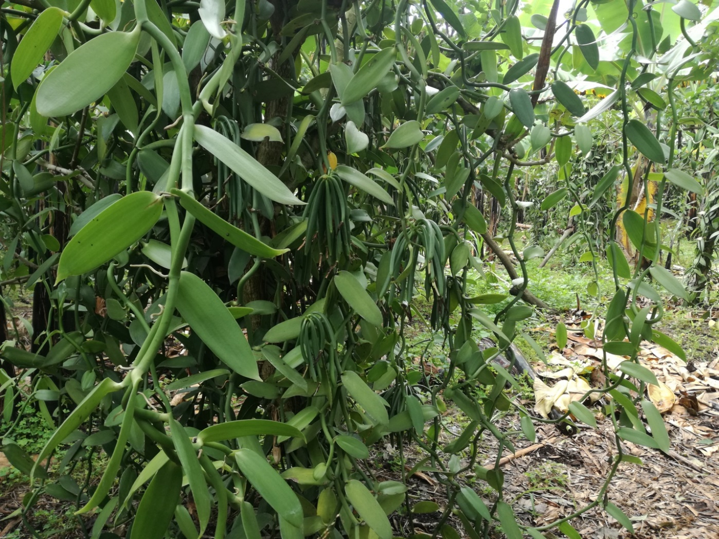

20 July 2019
Kampala, Uganda



Executive summary
The International Institute of Tropical Agriculture (IITA) has worked with smallholder coffee farmers over time to improve the production and productivity of coffee in the Eastern, Central, and Western parts of Uganda. In collaboration with public and private partners IITA developed the Stepwise approach that has been used to train farmers and give them management options for increased coffee production and resilience to the effects of climate change. IITA Uganda and Catholic Relief Services (CRS) are collaborating as implementing partners to develop climate smart investment pathways (Stepwise) that are aligned with the capacity and willingness of individual coffee and vanilla farming households.
Crop diversification is an effective climate adaptation strategy that helps farmers to spread market and production risks across a large number of crops. Studies around the world show that crop diversification increases productivity and stabilizes incomes of smallholders. In sub-Saharan Africa, crop diversification features prominently in many countries’ climate change adaptation strategies. Crop diversification has the potential to increase dietary diversity and food availability, thus contributing to improved nutrition. Through crop diversification, farming households can spread production and income risk over a wider range of crops, thus reducing livelihood vulnerability to weather and market shocks. Additionally, crop diversification can produce agronomic benefits in terms of pest management and soil quality, depending on the crop combination in the field.
The work on coffee and vanilla diversification is a sub-activity under the ARC Consortium with Sustainable Food Lab (SFL) and CRS. It includes the preliminary work necessary to develop a future proposal on effective approaches for resilient vanilla / coffee farming systems in Uganda, aiming at promoting intentional multi-commodity and food crop diversification by smallholder farmers. The sub-activity involves extracting preliminary information on the current state of existing recommendations and diversification models to develop well defined research questions, objectives, and activities for future use in the development of a long-term project on coffee/vanilla diversification. The first part of the sub-activity by IITA Uganda to review existing literature is documented in this report.

Contents
Executive summary 2
3
LITERATURE REVIEW 4
1. Introduction 4
2. Coffee farming systems 4
3. Production of Vanilla 4
3.1 Vanilla farming system 4
3.2 Limitations to vanilla growing 5
4. Coffee and vanilla diversification 5
5. Opportunities in Coffee and Vanilla production 5
6. Conclusion 5

LITERATURE REVIEW

Introduction
Crop diversification is the addition of new crops or cropping systems to agricultural production on a farm considering the different returns from value-added crops with complementary marketing opportunities (FAO, 2016). FAO 2018 looks at crop diversification as an effective strategy to deal with climate variability in which farmers increase the range of potential food and cash crops amid climate change. Diversification is the main strategy for combining higher production/unit area, with risk reduction and sustainability among farmers with smallholdings. In sub-Saharan Africa, crop diversification features prominently in the strategies of many countries for adaptation to climate change. Diversification spreads production and income risks over a wider range of crops, thus reducing livelihood vulnerability to weather and market shocks (FAO, 2018; World Bank, 2019). Moreover, depending on the crop combination, crop diversification can produce agronomic benefits in terms of productivity, pest management, and conservation of soil fertility and water. Therefore, more diverse systems can produce a combination of agronomic benefits in the soil, such as phosphorus enhancement and nitrogen fixation, from a range of crops, contributing to improved yields (Gram, 2017; FAO, 2018). However, additional studies show that no single system significantly decreases volatility in crop income, suggesting that this impact depends strongly on the agronomic attributes of the specific crop grown and on associated market structures (FAO, 2017; Thong Ho et al., 2017; World Bank, 2019)

Coffee farming systems
Diversified systems, particularly through crop diversification, may obtain higher yields and/or cause less environmental damage. This is known as the complementary or synergy effects among crops sharing the same environment. IITA has conducted several studies on coffee farming systems in Uganda such as a study on coffee cultivation systems and the potential of agroforestry as an adaptation strategy to climate change in Mount Elgon. The effects of three cultivation systems (i.e., Coffee-Open, Coffee-Banana, and Coffee-Cordia) were assessed on (i) the cultivation environment, (ii) water consumption of coffee, (iii) water consumption of banana (Musa sp.) and Cordia africana, and (iv) water competition or complementary use between coffee and shade tree species (Sarmiento-Soler, 2019). From this study, high temperatures and longer dry seasons in combination with reduced access to forest products at lower altitudes appeared to be the main drivers for increased adoption of coffee-tree systems. Furthermore, the socio-economic status of farmers influenced the type of system adopted; poor farmers preferred high intercropping (either with banana and/or shade trees) to diversify income and reduce risks related to open systems; wealthier farmers mainly owned open canopy coffee systems (Rahna, 2018).

Production of Vanilla
The vanilla genus consists of about 100 species. However, only three varieties of commercial vanilla are grown for their fruit: Vanilla planifolia, V. tahitensis and V. pompona. The first named species, V. planifolia, has the most commercial value (FAO, 2009). Like most orchids, vanilla is a shade-loving plant; it prefers 50 to 60% shade and good to strong indirect light. The traditional method for cultivation is to grow vanilla on a low-branching shrub or tree called the ‘tutor’. The tutor supports the vine and provides the desired shade. However, to make it more accessible to pollination and for harvesting the beans the plant needs to be trained to a height of not more than 1.2 to 1.35 m with a maximum height of not more than 1.5 m. As the vines grow up to 1.5 m, they are looped to encourage flowering. The pollination, harvesting, and curing of vanilla is a very labor-intensive process. The hand pollination method is still the only reliable method used to pollinate the flowers. This task is carried out each morning during the flowering season as the flowers open. Flowering may occur over a two to three-month period (Biradar, 2014). Care must be taken not to over-pollinate the flowers as this can result in the beans failing to mature and the vine dying. Harvesting is done six to nine months after flowering and pollination, when the tips of the bean starts to turn yellow and the remainder of the bean takes on a less-green color, changing towards yellow. The beans are harvested progressively by hand as they ripen. Late harvesting could lead to a high number of split beans- lowering the value considerably. Harvesting too early could lead to poor-quality beans in terms of aroma and flavor characteristics as the vanillin content is lower (ISSI, 2010).

Vanilla farming system
The agroforestry system consists of upper-storey shade trees with perennial crops such as coffee and banana. The common upper-storey shade trees are Ficus natalensis, Albizia coriaria, A. chinensis, Maesopsis eminii, and Spathodea campanulata. Vanilla requires trees (tutors) for support (Esegu, 2000). However, trees which are planted to provide shade should not be used as support trees. Jatropha curca,s the best support tree, is used by most farmers. Other support trees include Manihot esculenta, Ficus natalensis, Vernonia amydalina, Gliricidia sepium, Senna sp. and Cedrella odorata. Jatropha curcas is considered the best support tree because propagation is easy using cuttings, its extensive branches provide shade, it does not grow too tall and it can be used as a live fence (Esegu, 2000). Furthermore, it is resistant to termites. Once vanilla is established, management needs are limited except for pollination which requires a lot of labor and good skills (Komarek, 2010).

Limitations to vanilla growing
Limitations include lack of information on production and management, market information and prices, drought due to climate change, theft of the premature beans, and limited human resources to provide extension services. Furthermore, vanilla is not a priority research crop for the national research bodies, hence there is little to no research around the crop. Pollination is not only labor intensive, but also needs skill to ensure the right process is done (Komarek, 2010). Price fluctuations are a major challenge.

Coffee and vanilla diversification
On-farm diversification can contribute to improved resilience to climate-related risks. Productive diversification leads to greater diversity of crop resources and soil biota on the farm and across the wider agroecosystem. Biodiversity increases the resilience of agroecosystems to climate-related stressors and shocks by providing a variety of traits such as tolerance to drought or cold, and by generating key ecosystem services such as nutrient cycling, soil carbon sequestration, or biological pest and disease control, among others (Singh, 2013; Gram, 2017; World bank 2019). Diversification thus contributes to improved agroecosystem functioning and health which lead to enhanced agricultural productivity, reduced variability in production, and increased yields and incomes. In both the vanilla and coffee industry, small-scale producers are vulnerable to commodity price volatility and the increasing risk of climate variability. Many stakeholders have identified diversification as a key strategy for resilience to climate and market volatility in both coffee and vanilla, but efforts are often one-sided, failing to equip farmers with the resources or markets to successfully manage and sell one crop, in this case vanilla, while favoring a primary crop, e.g., coffee (Komarek, 2010; CRS, 2019). A study by CRS found that the main drivers of diversification and intercropping were food security, increased incomes, soil fertility enhancement, scarcity of land; and the need for shade trees.

Opportunities in Coffee and Vanilla production
Studies done by CRS in Madagascar show various opportunities in vanilla growing as a profitable business for smallholders (CRS, 2013). In Madagascar, Bourbon vanilla is a high-value crop on as little as 0. 5 ha of land, with average annual net income potential of $1,500–5,800/ha for green vanilla, and $3,000–9,990 for cured vanilla over a six-year period. Cash income generated from vanilla can help farming families ensure food and income security. As a perennial, vanilla provides equitable sustainability from a lasting economic asset of a minimum of 10 annual harvests/ plant over 13 to 15 years. The plantations can be renovated during this time, allowing them to thrive far beyond the 15-year vegetative cycle of this first planting. Developing secondary cash crops in the same agroforestry system would be an additional risk mitigation buffer to ensure a consistent income stream all year-round. Since vanilla is shade tolerant, environmental conservation is improved. Increased vegetative and tree canopy cover makes vanilla a viable livelihood mechanism to protect water, forests, and soil in the era of climate change. Vanilla is also a good companion crop and can grow well together with coffee, banana, and shade trees (Esegu, 2000; Ssebunya, 2011; CRS, 2013). Vanilla’s shallow root systems enables it to coexist well with other crops and trees as part of an intercropped agroforestry system. Farming families on small plots can increase their income security while still growing annual staple and perennial food crops. Given the requirements for manual pollination and the multistep postharvest period stretching over two to six months, vanilla is a high provider of employment with benefits going beyond the family to the entire community.

Conclusion
Diversification encourages the inclusion of smallholders in agricultural value chains at different scales, leading towards higher-value crops and a gradual movement into the non-farm sector (Djurfeldt, 2018). Diversified systems, particularly through crops, may obtain higher yields and/or cause less environmental damage. These are known as complementary or synergy effects among crops sharing the same environment. Since appropriate crop diversification strategies can deliver the positive effects of synthesis, it could be expected that coffee farmers would be motivated to diversify by growing industrial crops, such as vanilla, which may also mitigate market risk (Thong Ho, 2017). Crop diversification in synchronized systems has the potential to deliver agronomic and ecological benefits; however, realizing these potential benefits depends on the characteristics of ecosystems and the choice of crops.
In conclusion, diversification of coffee and vanilla can provide farmers with options for food and income security and environmental and natural resource conservation which result in resilience and adaptation to climate change in the end.

References
.Agnes Andersson Djurfeldt, F. M. (2018). Perspectives on Agriculture, Diversification, and Gender in Rural Africa: Theoretical and Methodological Issues Agnes Andersson Djurfeldt, Fred Mawunyo Dzanku, and Aida Cuthbert Isinika. In F. M. Agnes Andersson Djurfeldt, Agriculture, Diversification, and Gender in Rural Africa: Longitudinal Perspectives from Six Countries Edited by Agnes Andersson Djurfeldt, Fred Mawunyo Dzanku, and Aida Cuthbert Isinika (p. 265). Oxford: Oxford Univerity Press.
.Alejandra Sarmiento-Soler, P. V. (2019). Water use of Coffea arabica in open versus shaded systems under smallholder’s farm conditions in Eastern Uganda. Agriculture and forest metereology, 231-242.
.CRS. (2013). Revitalising vanilla in Madagascar: Report on a feasibility study to enhance small farmer participation in the vanilla value chain. Baltimore: CRS.
.CRS. (2019). Vanilla coffee diversification. Kampala: unpublished.
.Eric Rahna, T. L.-S. (2018). Opportunities for sustainable intensification of coffee agro-ecosystems along an altitudinal gradient on Mt. Elgon, Uganda. Agriculture, Ecosystems and Environment, 31-40.
.Esegu, I. O.-A. (2000). Agroforestry handbook for the banana coffee zone of uganda: Farmers' practices and experiences . Nairobi: Regional Land Management Unit .
FAO. (2009). Vanilla post harvest management. Rome: FAO.
.FAO. (2016). Madagascar and FAO: Supporting regional development for food and nutrition improvement and resilience in Madagascar. Rome: FOA.
.FAO. (2018). Crop diversification increases productivity and stabilizes income of smallholders. FAO Agriculture Economics Policy brief. www.fao.org/economic/esa/policy-briefs. Retrieved from Economic and Policy Analysis of Climate Change (EPIC) www.fao.org/climatechange/epic epic@fao.org: Economic and Policy Analysis of Climate Change (EPIC) www.fao.org/climatechange/epic epic@fao.org
.Gil Gram, P. VanAsten. (2017). Local tree knowledge can fast-track agroforestry recommendations for coffee smallholders along a climate gradient in Mount Elgon, Uganda. Agroforestry systems, 92(6), 1625-1638.
I. B. Biradar, Y. R. (2014). Diversification in Coffee Estates by Growing Medicinal and Aromatic Crops. Research Journal of Agricultural Sciences, 5(6), 1194-1195.
.ISSI. (2010). Vanilla production, processing and packaging. Vanilla 2009 conference (p. 26). New jersey: ISS Institute.
.Komarek, A. M. (2010). Crop diversification decisions: the case of vanilla in Uganda. Quarterly Journal of International Agriculture, 49(3), 227-242.
.Singh, N. S. (2013). Agriculture diversification and contract farming in Punjab. Journal of economic and social development, 9(1), 38-51.
Ssebunya, P. V. (2011). Coffee. In FiBL, African organic agriculture training manual (pp. 9-31). Geneva: FiBL.
.Thong Ho, C. W.-N. (2017). Which farming systems are efficient for vietnamese coffee farmers? Economic analysis and policy, 13.
.Worldbank. (2019). Productive Diversification in African Agriculture and its Effects on Resilience and Nutrition. Washington: World Bank.

